Learn to use Audacity
Lesson Plan for learning how to create content with Audacity
Don Watkins

OVERVIEW & PURPOSE
The student will learn how to install Audacity to their Linux computer. They will learn how to find content which may be modified and re-shared legally.

EDUCATION STANDARDS
- ISTE Learning Standard - 3C - Students curate information from digital resources using a variety of tools and methods to create collections of artifacts that demonstrate meaningful connections or conclusions.

OBJECTIVES
- Student will learn how to install Audacity from the software store and command line.
- Student will learn how to find and download free resources which may be modified.

MATERIALS NEEDED
- Linux Laptop
- Audacity application installed - $sudo apt install audacity or $sudo dnf install audacity
- Access to the Internet
- Creative Commons Free Music Archive - https://freemusicarchive.org/curator/Creative_Commons

Instructions
- Download music track from the free music archive.
- Write a poem or short story. You can also choose to go to Project Gutenberg and download a poem or other literature that is in the public domain.
- Example poem by Kahlil Gibran.
- Download in text format.
- Launch Audacity and press the ‘Record’ button which is the ‘Red dot’ below
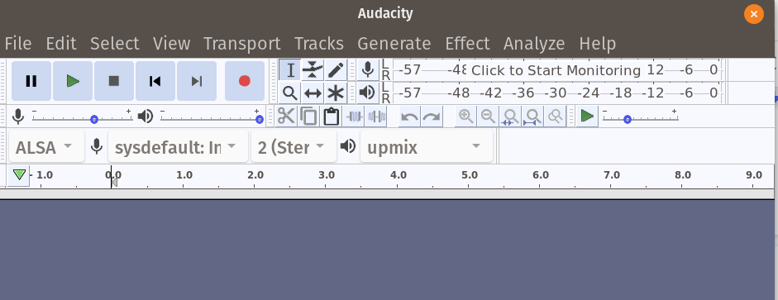
- Read the poem. When complete stop the recording by pressing the ‘Stop’ button which is third from the left.
- Using the ‘File’ menu ‘Save’ the file as an ‘aup’ for further editing or export the file in your favorite format.

Further Study
Further study : https://opensource.com/education/16/9/audacity-classroom

This work is licensed under a Creative Commons Attribution 4.0 International License.

